**Dockerize a simple PHP application and deploy it on an AWS EC2 instance. This application will interact with a MySQL database hosted on AWS RDS:**

### **1. Create a PHP Web Application:**

1. Creating Ec2 Instance

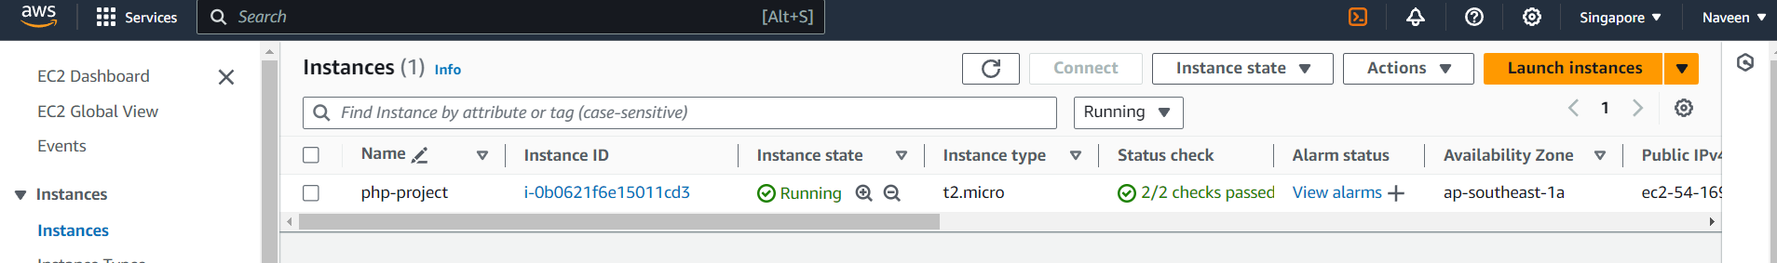

**Clone a Simple PHP Application from GitHub**:

**git clone** [**https://github.com/naveengoud0414/simple-php-website.git**](https://github.com/naveengoud0414/simple-php-website.git)

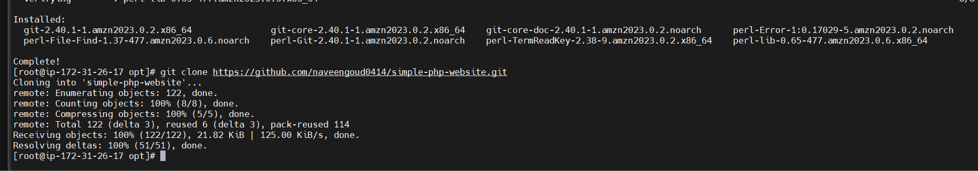

1. **Set Up Project Structure:**

**mkdir simple-php-app**

**cd simple-php-app**

**touch index.php submit.php config.php**

**config.php**

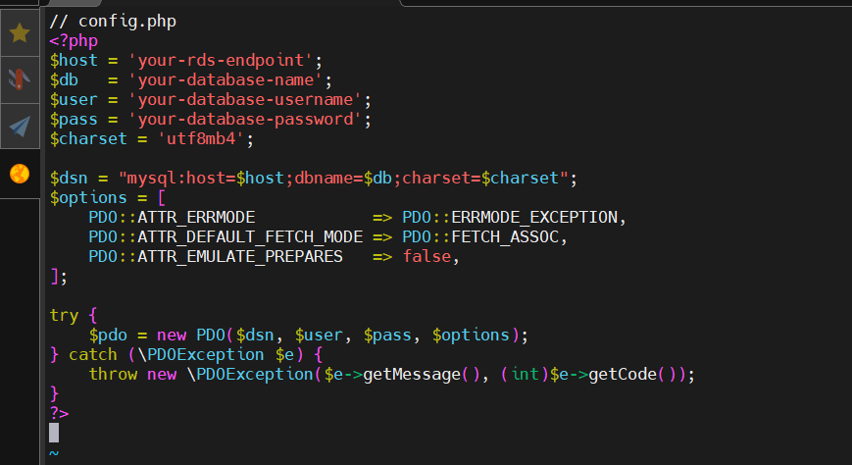

**index.php:**

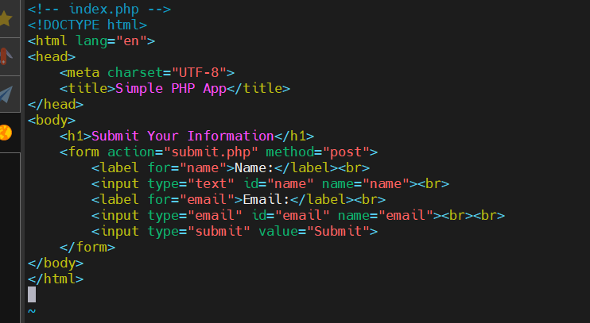

**Submit.php:**

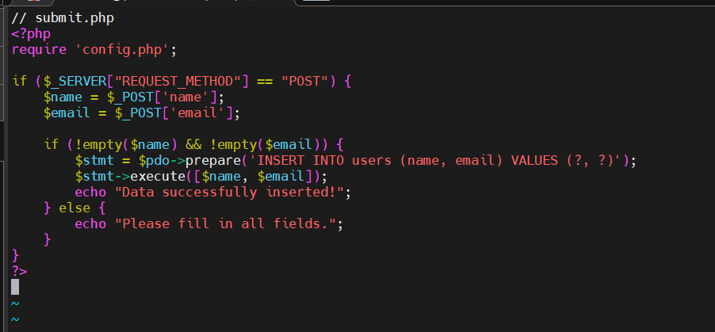

### **4. Dockerize the Application**

1. Create a Dockerfile:

Creating the docker file using official PHP Docker image

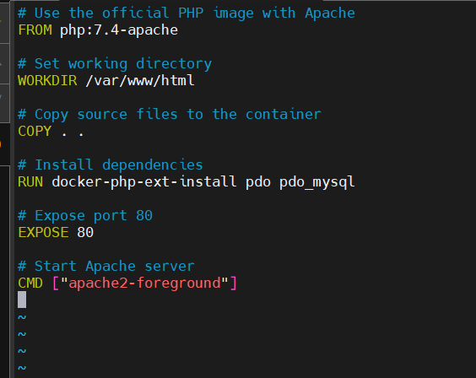

**Set Up MySQL Database on AWS RDS:**

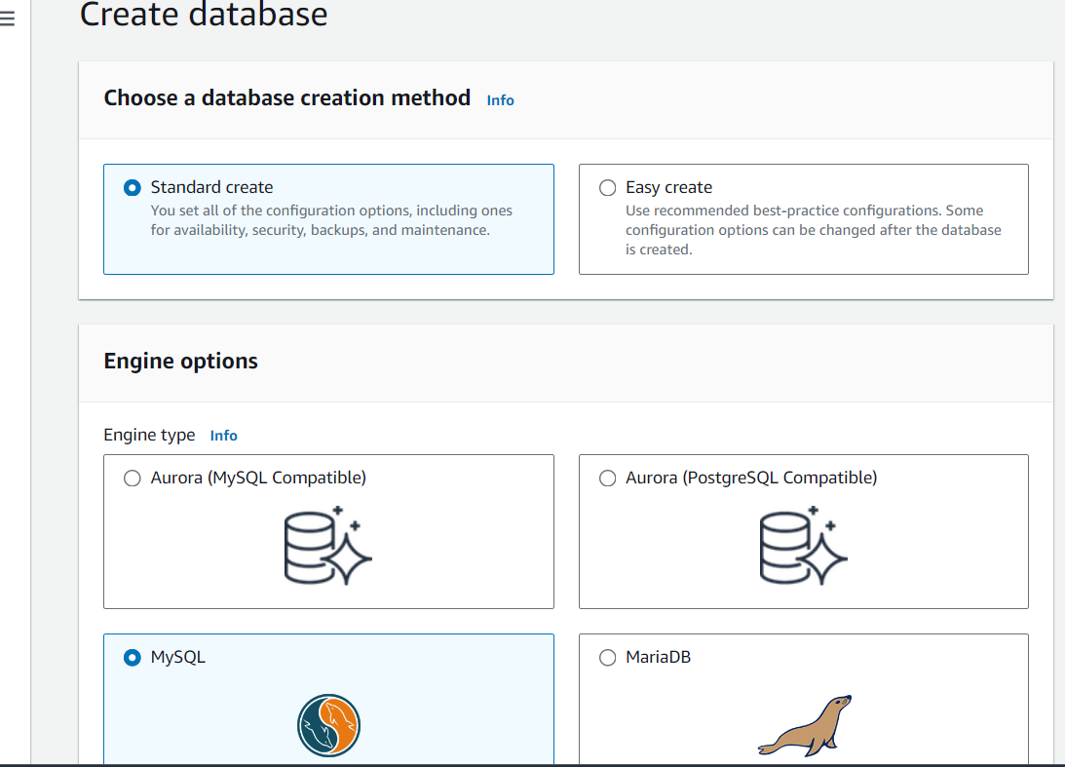

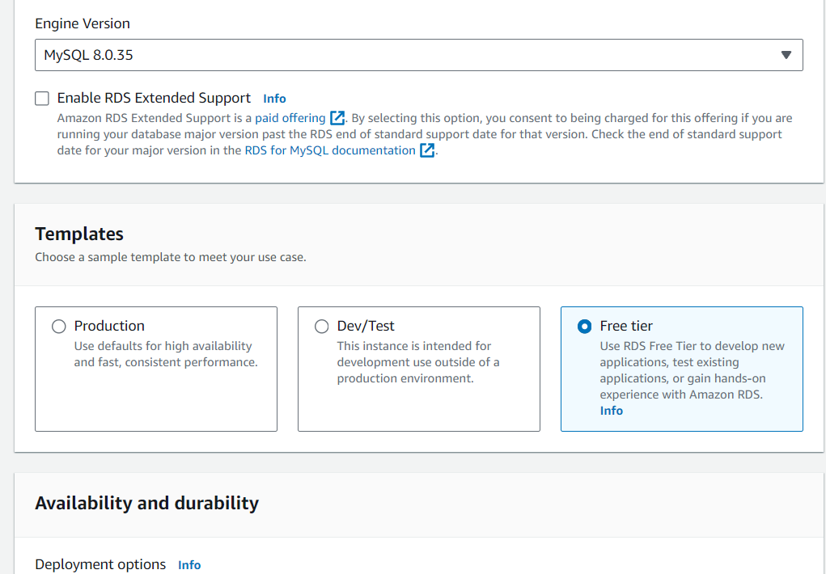

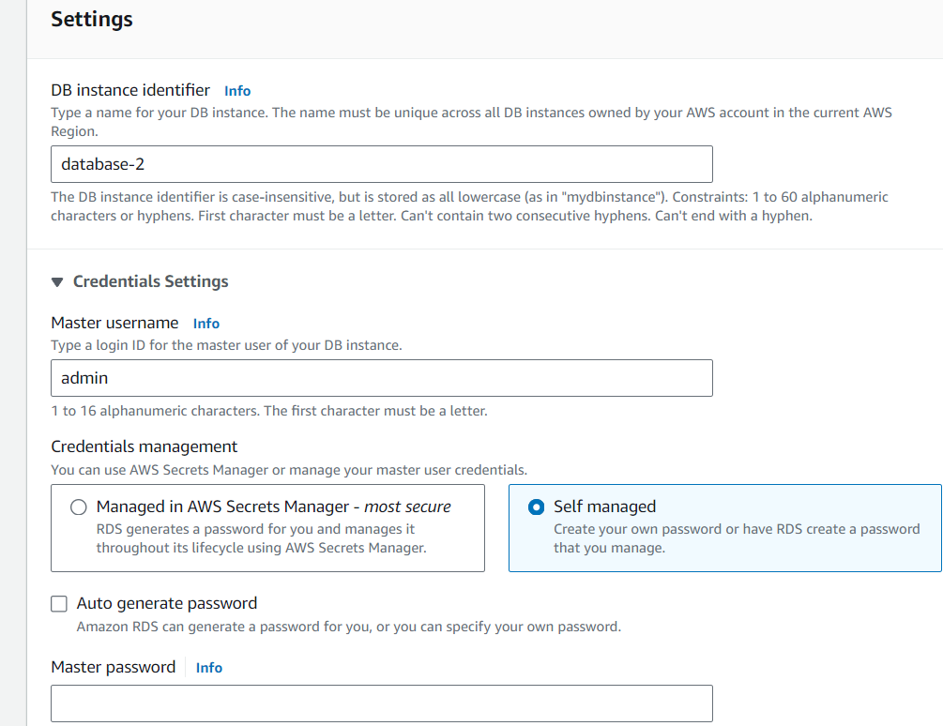

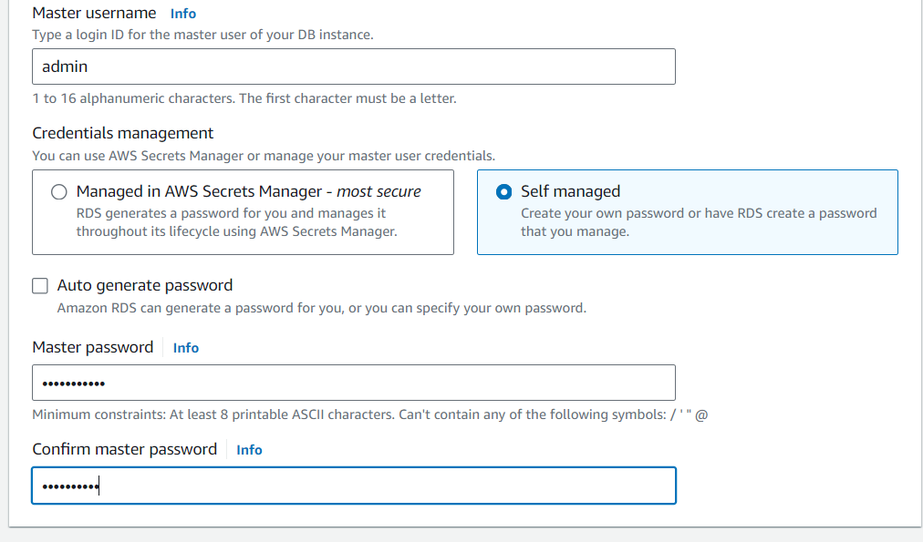

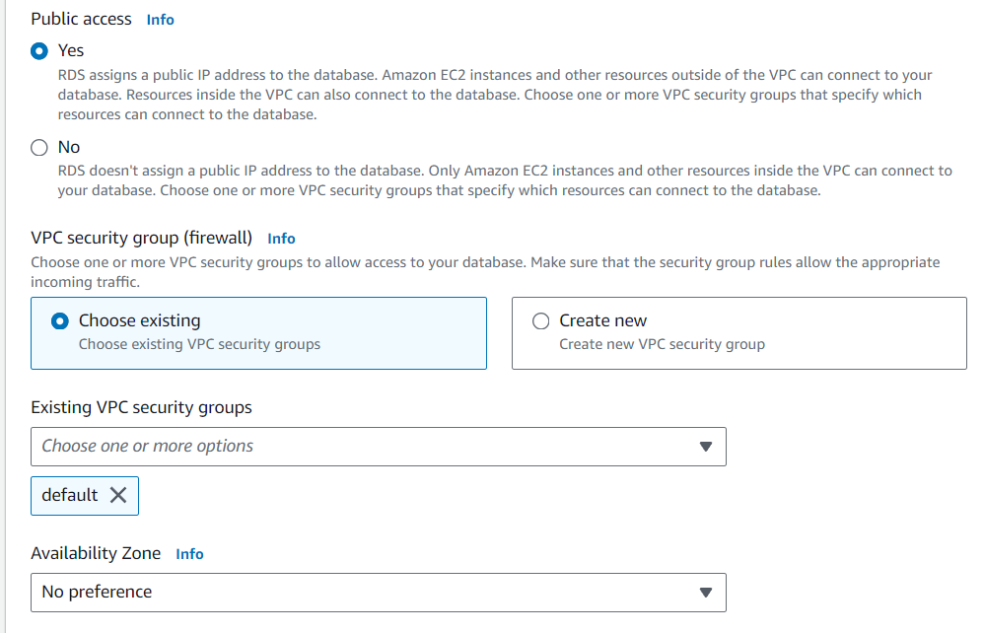

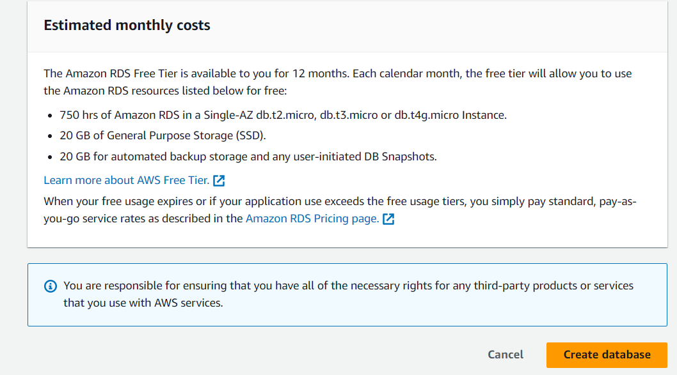

**After create the Data Base:**

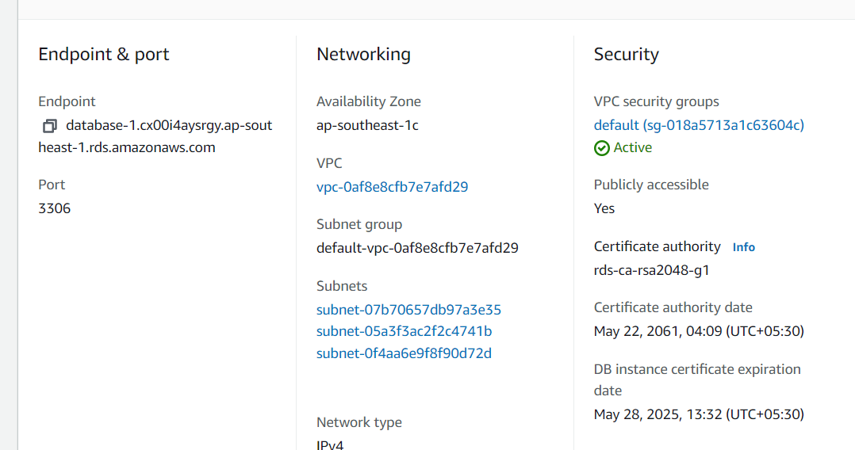

**Configure the Rds details in to created configurations:**

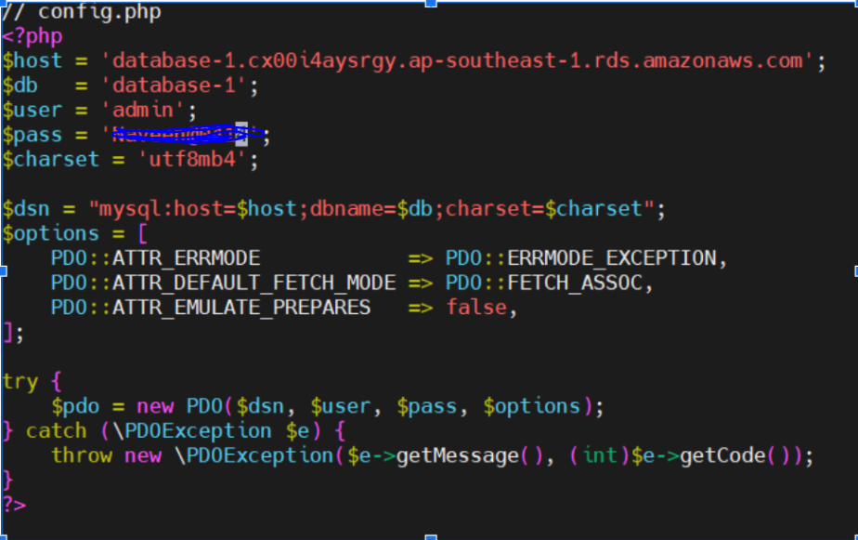

**Push to git hub:**

**git init  
 git add .**

**git commit -m “php”**

**git config - - global user.name “naveen…0414”**

**git config --global user.gmail “**[**naveenarvapalli0414@gmail.com**](mailto:naveenarvapalli0414@gmail.com)**”**

**git remote add origin** [**https://github.com/naveengoud0414/PHP-application-and-deploy-it-on-an-AWS-EC2-instance.git**](https://github.com/naveengoud0414/PHP-application-and-deploy-it-on-an-AWS-EC2-instance.git)



**git push origin master  
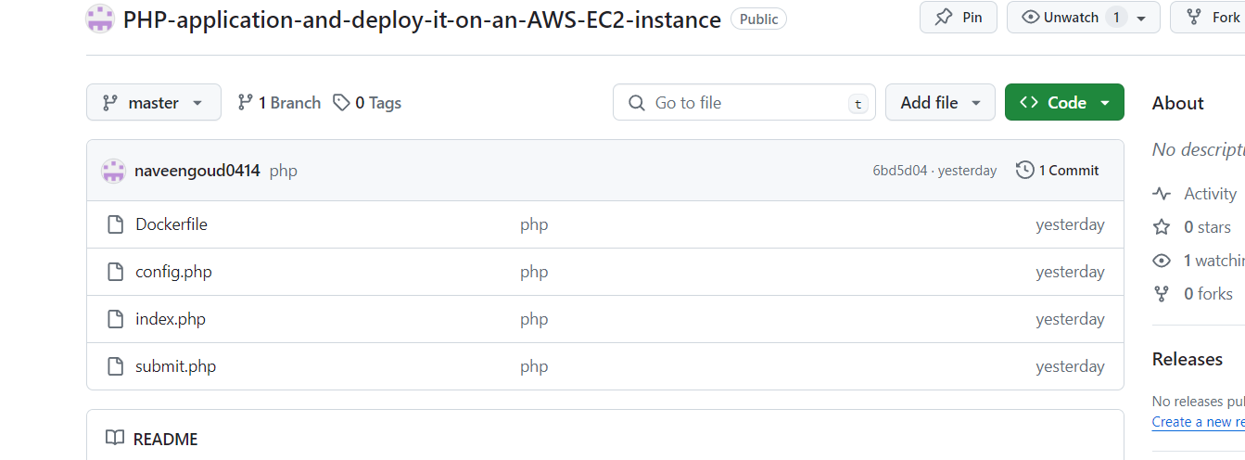**

**docker installation:**

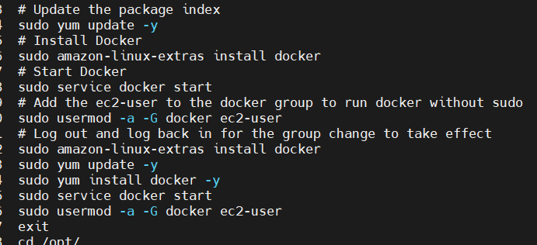

**Docker compose file:**

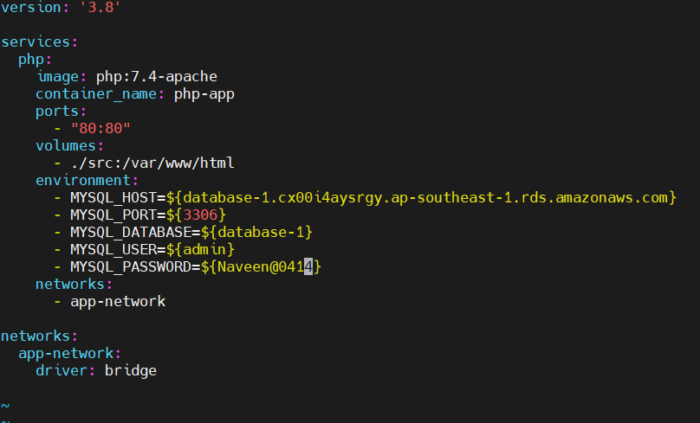

**Creating ECR by using AWS CLI:**

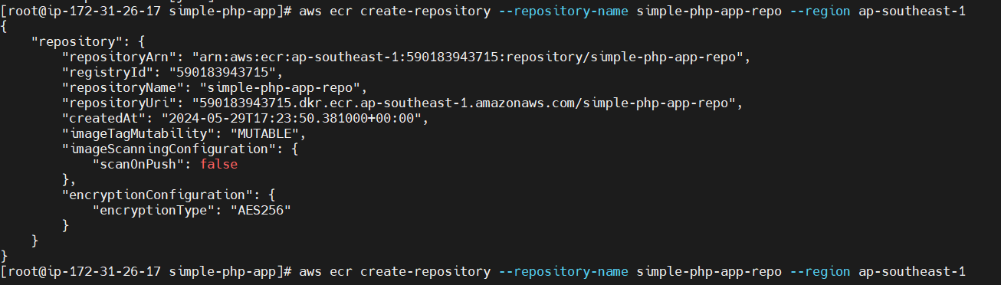

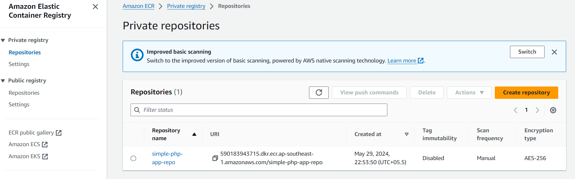

**Configuring the SSH Pem.file:**

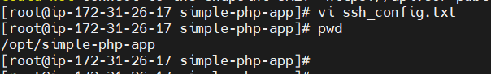

**Jenkins installation:**

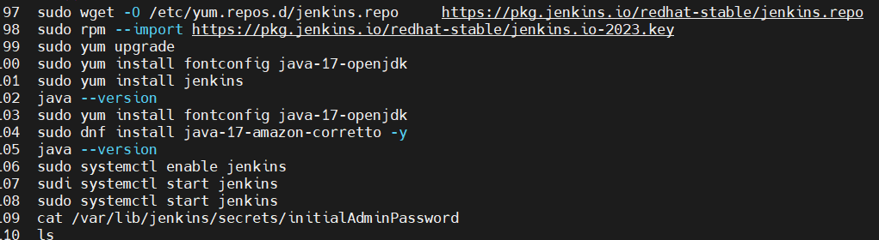

**Creating Jenkins pipeline and deploy ec2 and ECR:**

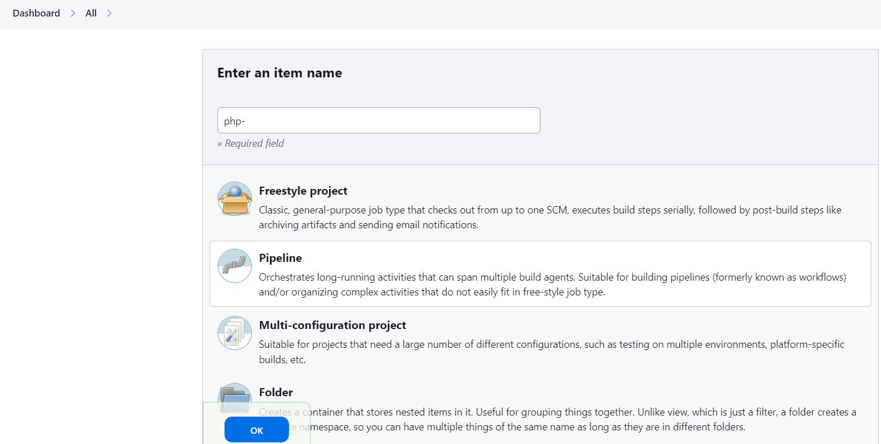

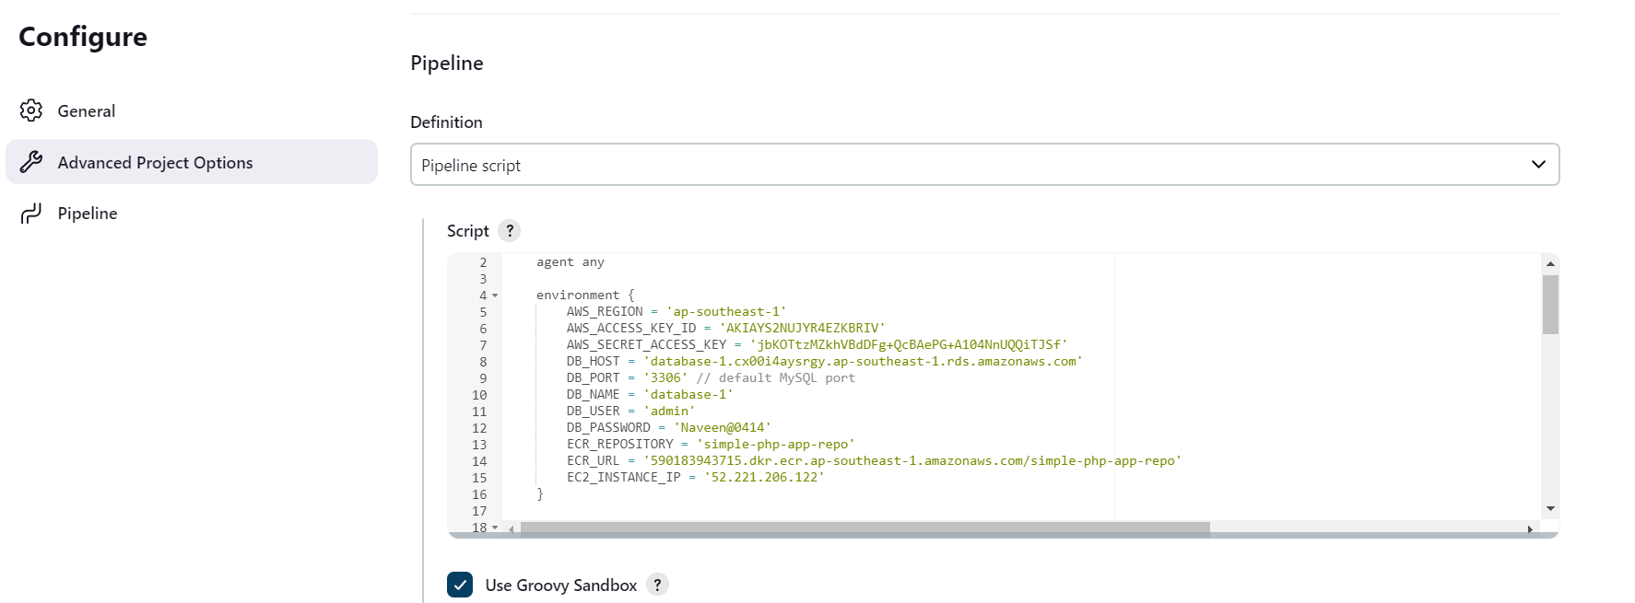

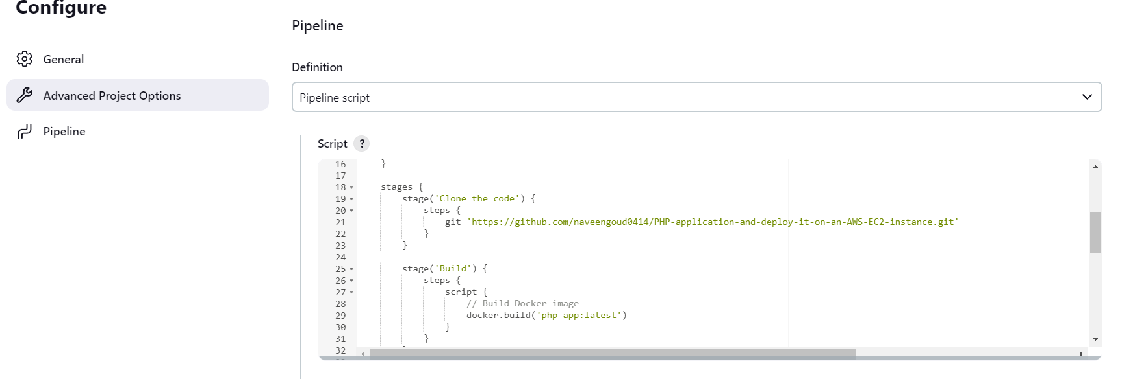

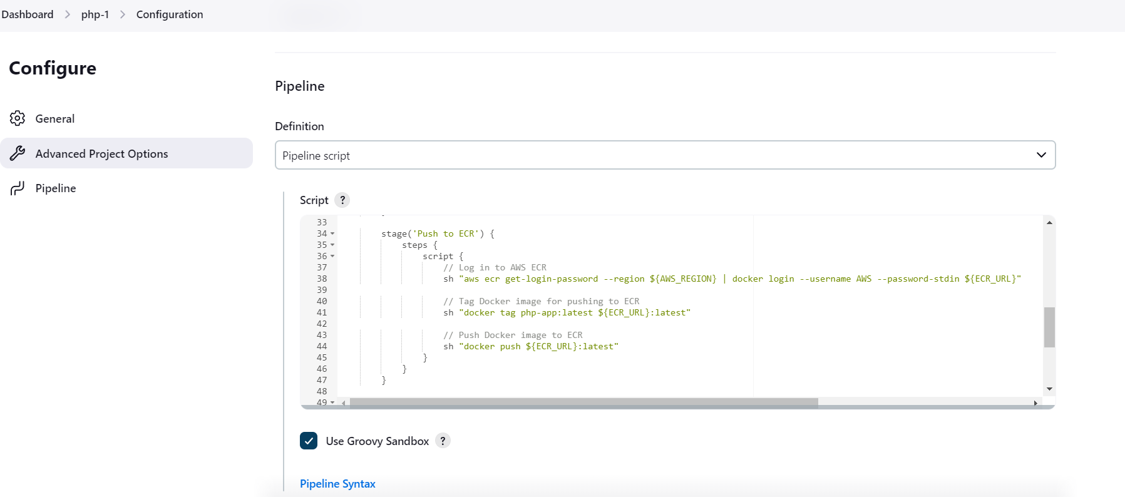

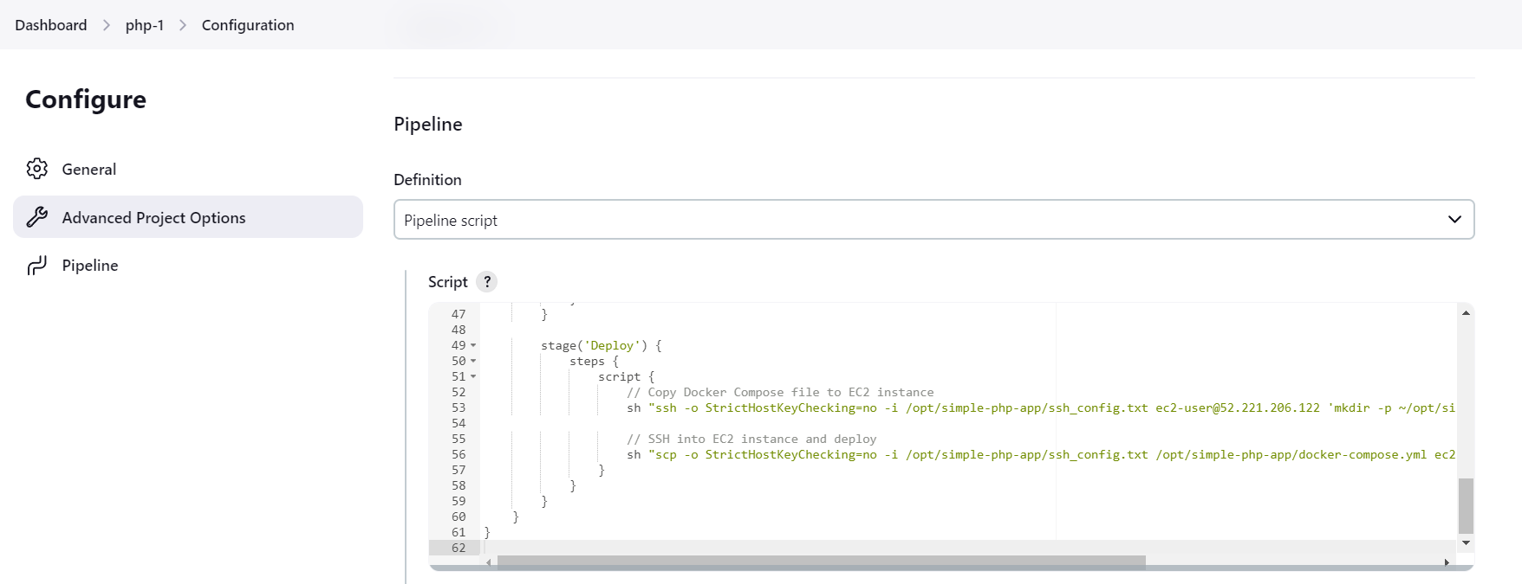

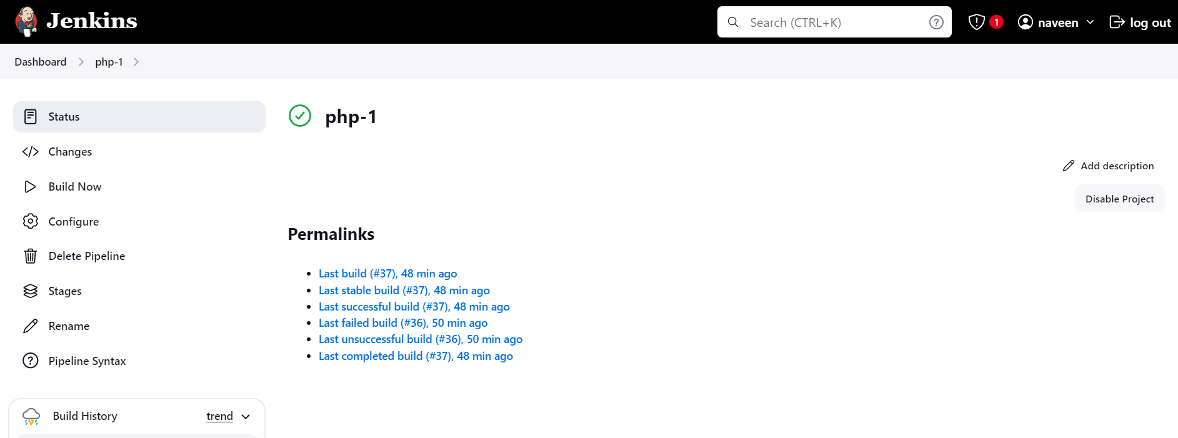

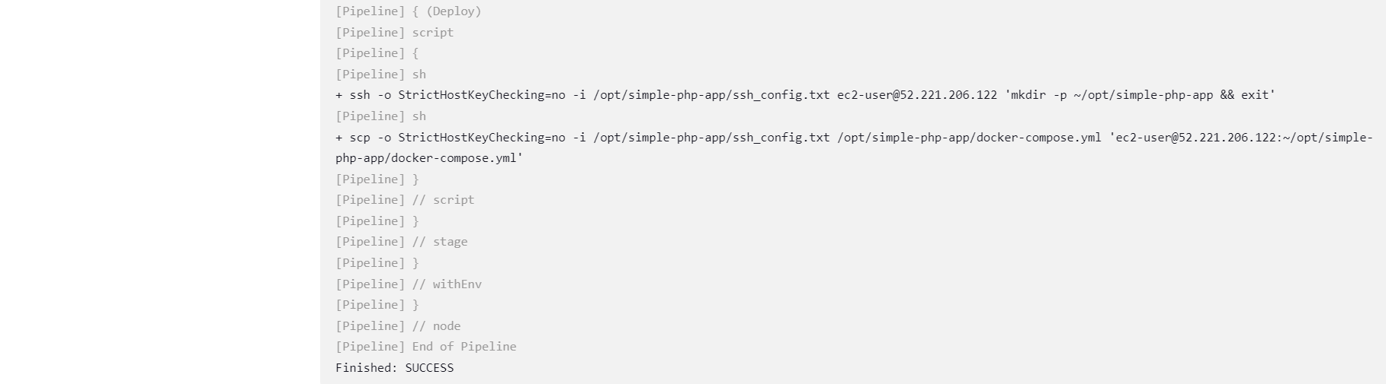

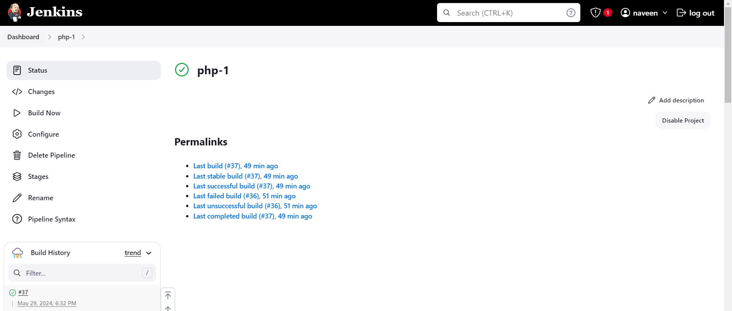

**Successfully deployed ec2:**

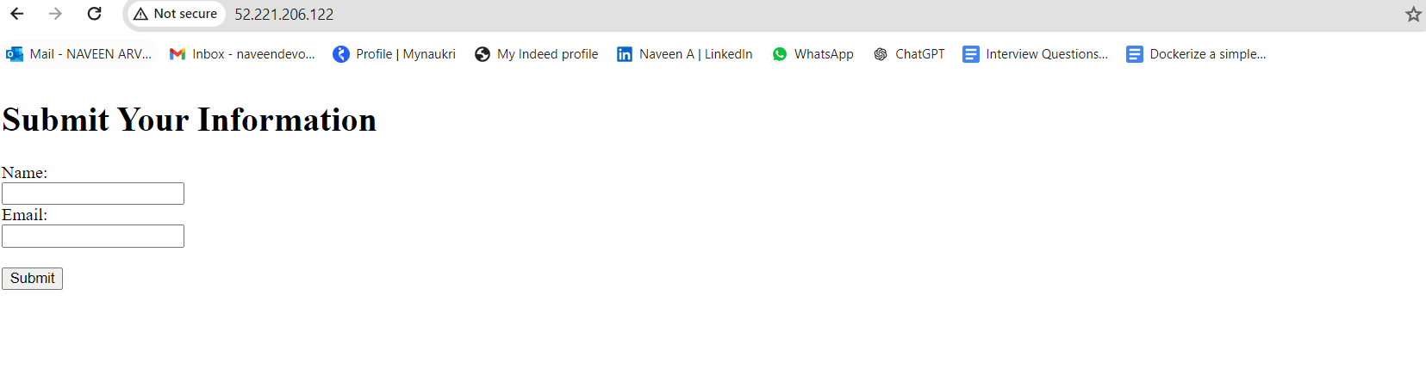

**ECR:**

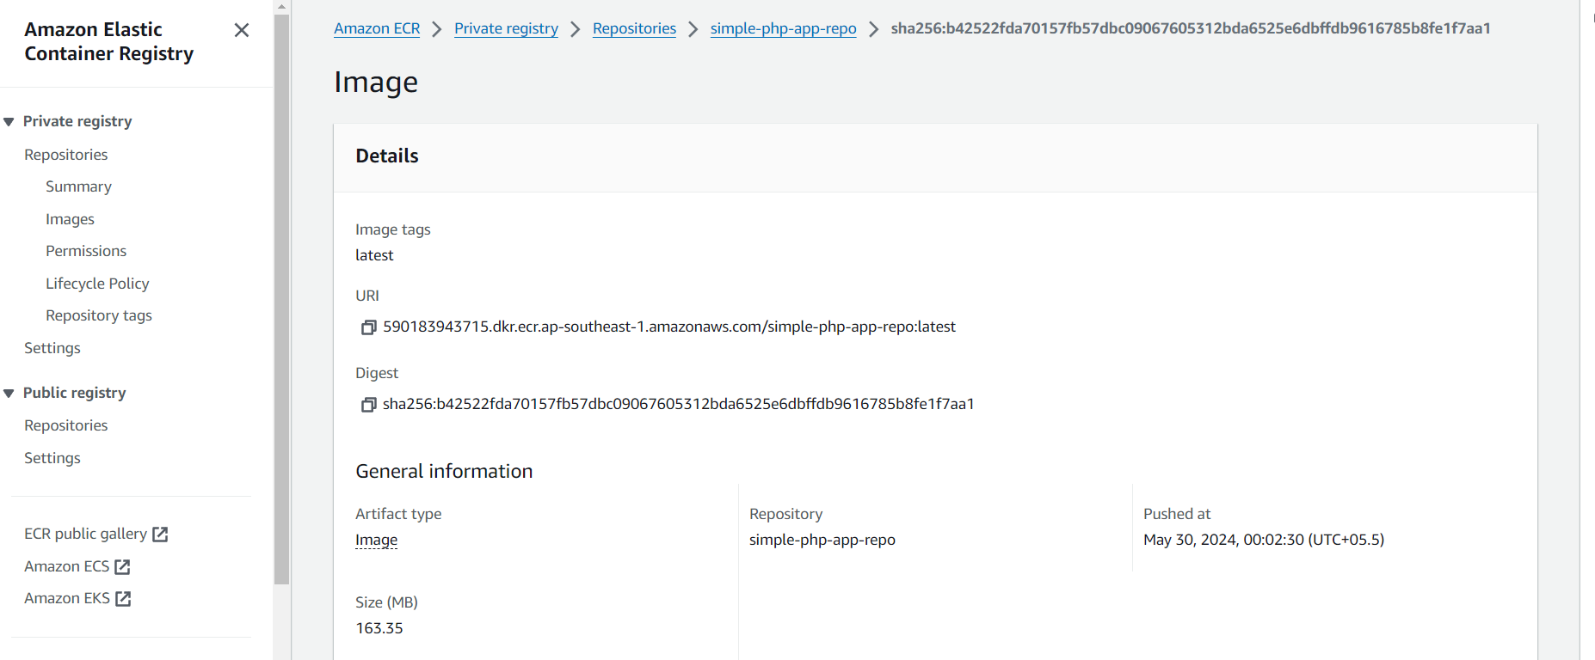

**docker images locally:**



**Docker containers:**



**AWS RDS:**

